**MODULE 1: CRIME TYPE AND LOCATION DESCRIPTION**

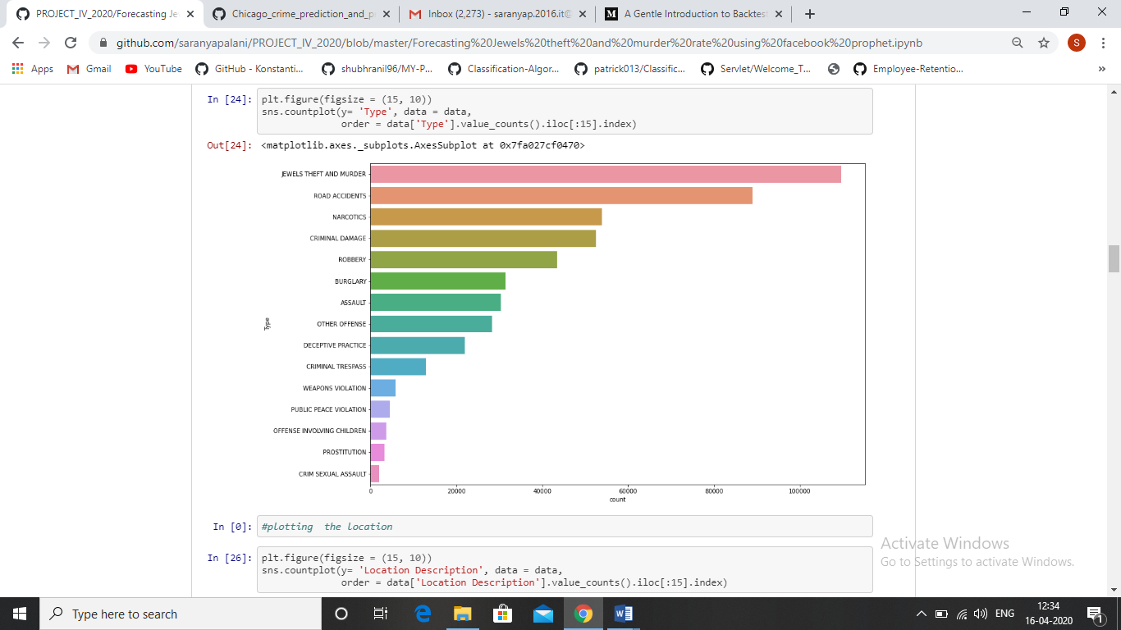

Figure 1

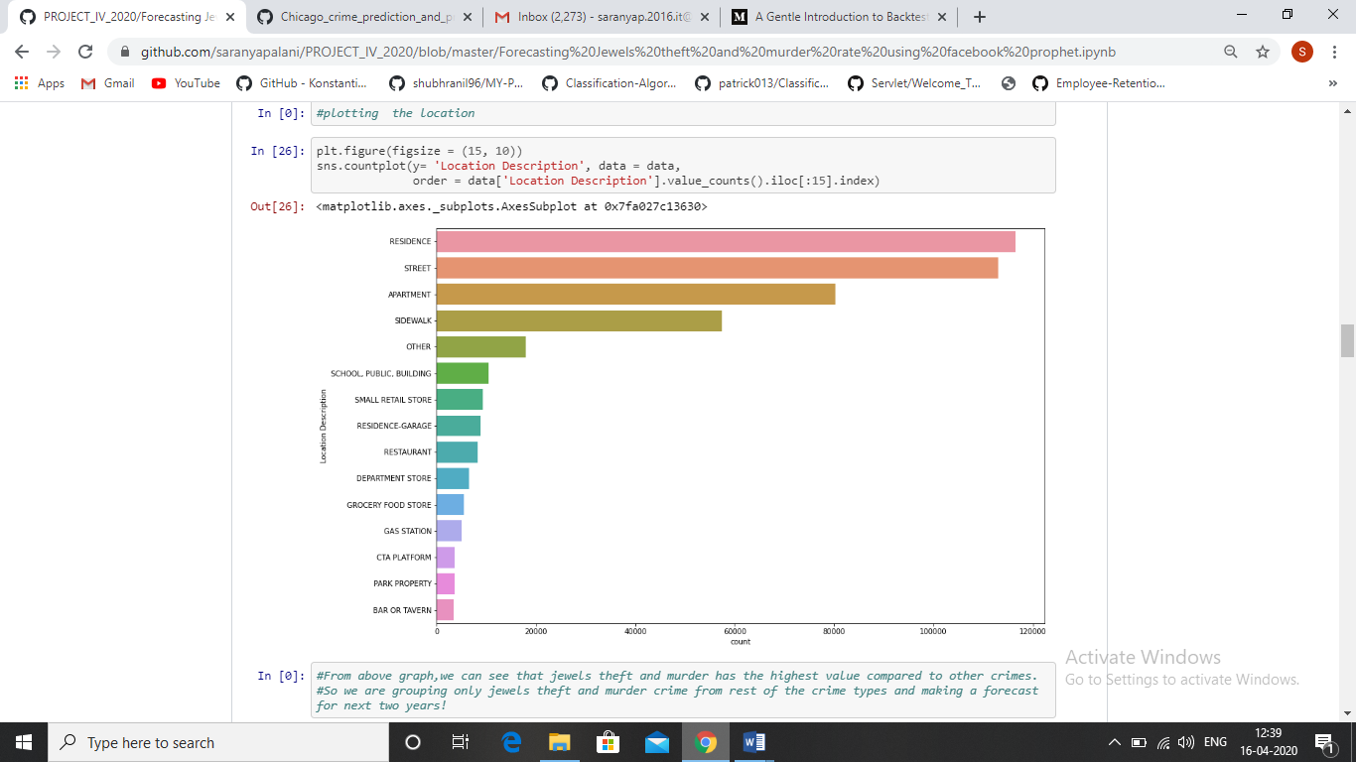

Figure 2